19-Ecosystem Fluxes

To make comparisons with other models of carbon dynamics LANDCARB produces additional output variables related to ecosystem fluxes including gross primary production (GPP), net primary production ( NPP), autotrophic respiration (Ra), mortality (M), heterotrophic respiration (Rh), and net ecosystem production (NEP). An example of how these fluxes or flows change over time is presented in Figure 19-1.

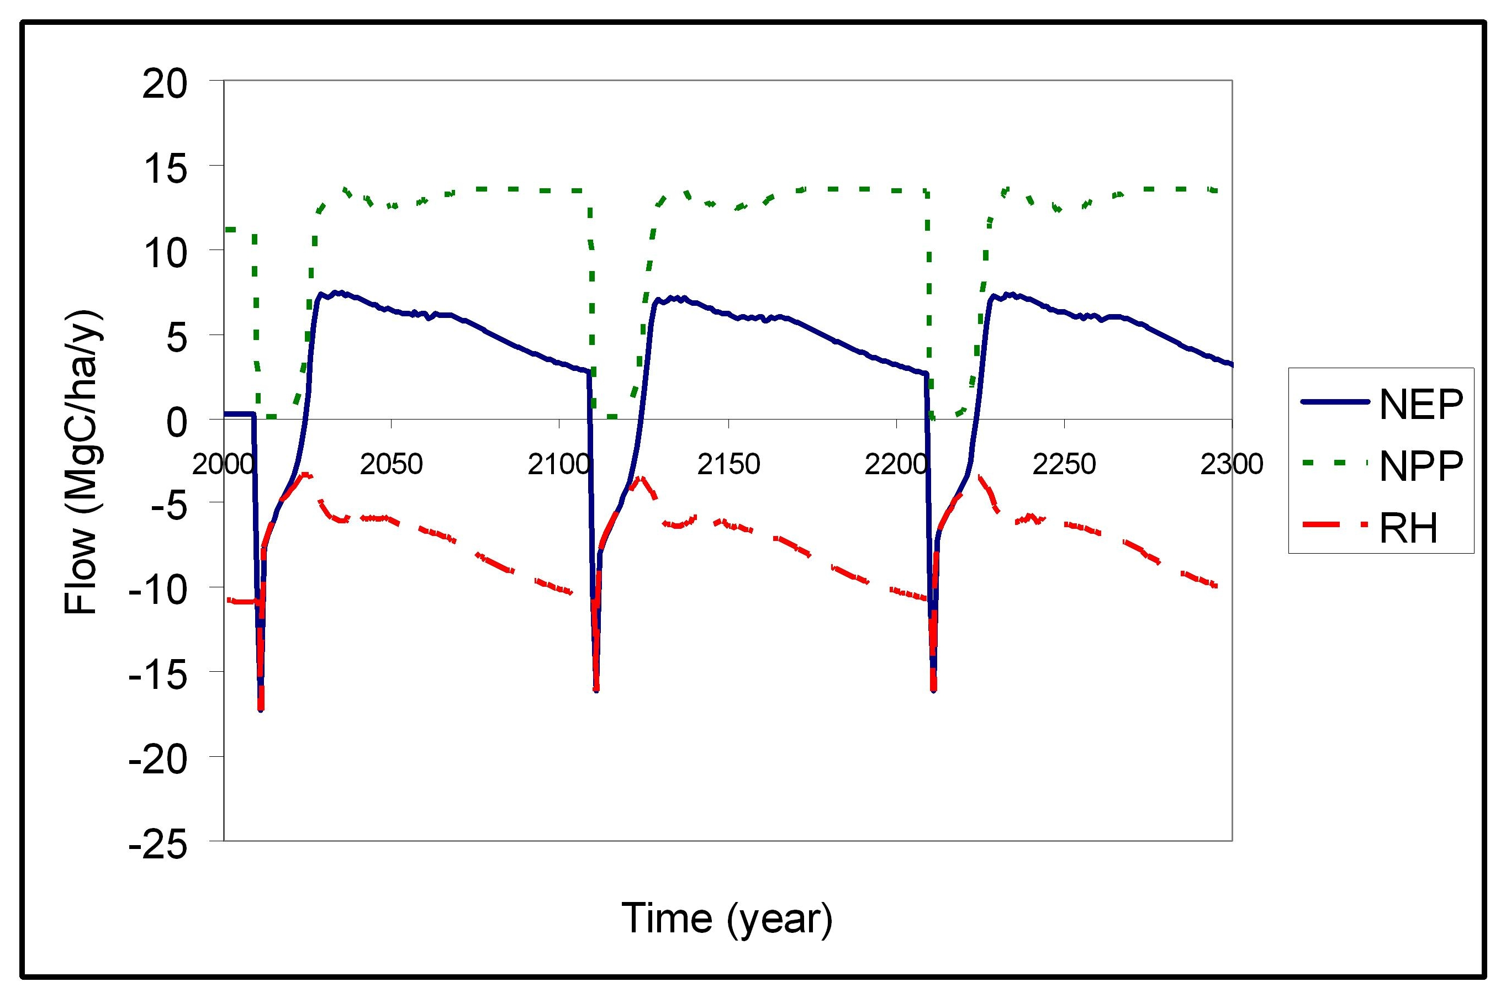

Figure 19-1. Changes in NPP, RH, and NEP in a forest after harvesting as predicted by the LANDCARB model.

NPP or Net Primary Production

NPP is calculated for all pools except the foliage, heartwood, and heart-rot as:

LayerPartNPP=LayerPartAlloc-LayerPartResp

Heartwood and heart-rot are not included in the NPP calculation because allocation to these pools does not involve the creation of new carbon or organic matter. For the foliage we need to use a different calculation because we do not have a gross allocation to leaves per se, but use a net allocation:

LayerFoliageNPP=LayerFoliageAlloc +LayerPartTurnover

TotalNPP= ∑ LayerPartNPP

Ra or Autotrophic respiration

Ra consists of two parts. The first is maintenance respiration MaintenanceRa which is for all plants parts accounted for by LayerPartResp. An exception is for foliage which is calculated as

LayerFoliageResp= LayerFoliageRespRate * LayerFoliage

To calculate MaintenanceRa one sums all the respiration for the different layers and parts

MaintenanceRa=∑ LayerPartResp

The second part of Ra involved construction-related respiration, which accounts for the fact that making different forms of organic matter from sugars has a metabolic cost. It is assumed that an average respiration cost of construction is 25% of NPP

ConstructionRa=0.25*TotalNPP

Ra is then the sum of these two forms of respiration

TotalRa= MaintenanceRa + ConstructionRa

M or Mortality

The mass of all plant parts dying is defined as mortality (M). For most of the time mortality is not associated with disturbances. Disturbance related mortality is not included in this output.

TotalM= ∑ LayerPartMort + ∑ LayerPartTurnover + ∑ LayerPartPrune

Where LayerPartMort accounts for losses associated with tree death, LayerPartTurnover accounts for losses associated with death of non-woody parts (i.e., foliage and fine roots), and LayerPartPrune accounted for death associated with non-stem woody parts (i.e., branches and coarse roots).

Rh or Heterotrophic respiration

This is the sum of all decay losses for the dead and stable pools and that associated with heart-rot decomposition.

TotalRh= ∑ PoolDecayLoss + ∑ StablePoolDecay +LayerHeartrotResp

GPP or Gross Primary Production

Gross Primary Production is essentially net photosynthesis. It is calculated as

TotalGPP= TotalNPP + TotalRa

NEP or Net Ecosystem Production

Net Ecosystem Production is the balance between production and respiration, in this case the difference of NPP and Rh:

TotalNEP= TotalNPP- TotalRh

Note that NEP does not account for losses other than RH, so if there is harvesting or combustion related carbon removals NEP will not equal the net carbon balance of a stand (NECB) (Figure 19-2).

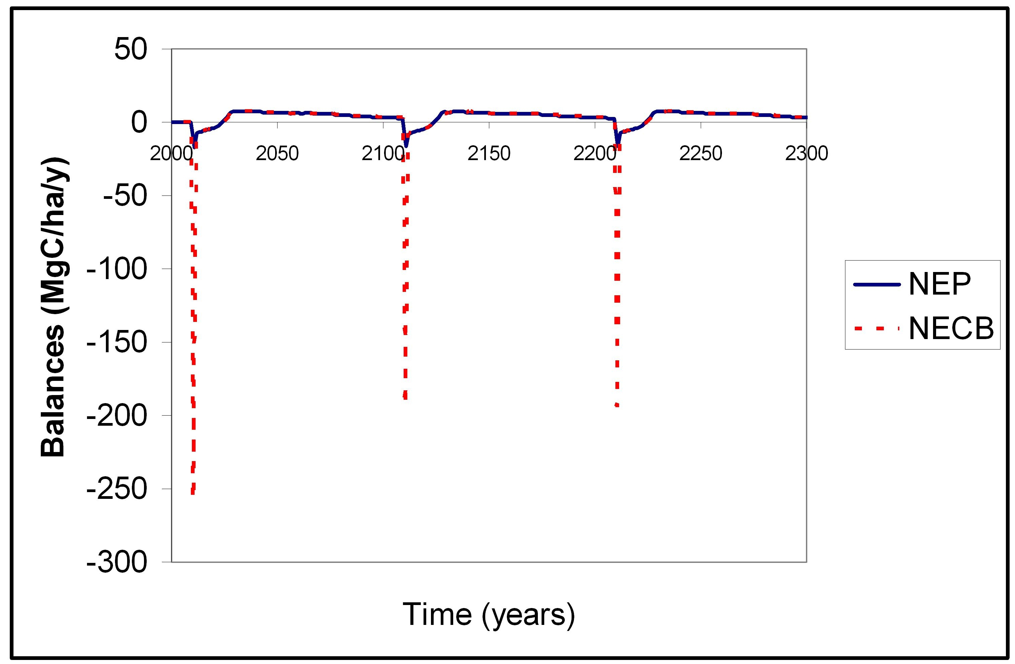

Figure 19-2. NEP and NECB are not the same when there are carbon losses other than respiration. In this example the forest is being harvested, and this leads to a large loss of carbon not captured by NEP alone.

